MCTR911 - Robotics Programming

Project Milestone 02 Report: Kinematic Analysis of UR5e

Project Title: Industrial Robotics Application with UR5e

Team : 7

1. Overview

This report details the work completed for Milestone 02 of the MCTR911 Robotics Programming project. The primary focus of this milestone was the kinematic analysis of the Universal Robots UR5e robotic arm, the implementation of its forward and inverse position kinematics in Python, and the initial setup of the ROS 2 simulation environment.

2. Frame Assignment and Denavit-Hartenberg (DH) Convention

Coordinate frames were assigned to the UR5e's six joints according to the Denavit-Hartenberg (DH) convention. The resulting DH parameters, which form the basis for all kinematic calculations, are presented in the table below.

Joint (i) αᵢ₋₁.(rad) aᵢ₋₁ (m) dᵢ (m) θᵢ (rad)

1 0 0 0.1625 q₁

2 π/2 0. 0 q₂

3 0 -0.425 0 q₃

4 0 -0.3922 0.1333 q₄

5 π/2 0 0.0997 q₅

6 -π/2 0 0.0996 q₆

Table 1: Denavit-Hartenberg Parameters for the UR5e Robot.

3. Forward Position Kinematics Analysis

Forward kinematics determines the position and orientation of the end-effector based on a given set of joint angles. This is achieved by calculating the homogeneous transformation matrix for each joint and sequentially multiplying them.

The transformation matrix

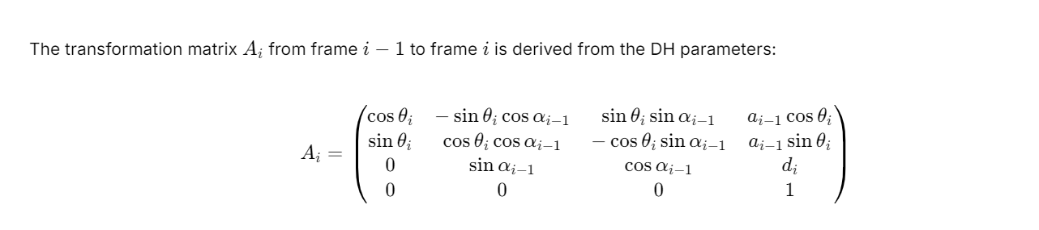

The final transformation from the base (frame 0) to the end-effector (frame 6) is the product of the individual joint transformations:

[ T^0_6 = A_1 \cdot A_2 \cdot A_3 \cdot A_4 \cdot A_5 \cdot A_6 ]

This calculation was successfully implemented in the forward_kinematics.py script using the numpy library.

4. Inverse Position Kinematics

Inverse kinematics calculates the required joint angles (q₁, ..., q₆) to place the end-effector at a desired target position in 3D space. Due to the complexity of deriving an analytical solution, a numerical approach was implemented using the well-established ikpy library. This implementation is provided in the inverse_kinematics.py script.